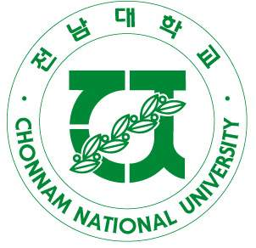 | CHONNAM NATIONAL UNIVERSITY  77 Yongbong-ro, Buk-gu Tel: +82-62-530-1273  Gwangju, South Korea 61186 Fax: +82-62-530-1269  E-Mail: shannon@chonnam.ac.kr
Visiting Scholar Application for CNU-ISS 2016

Application Deadline: December 4(Fri.), 2015

- Family Name Middle Name Given Name

Full Name Gender: Male / Female

2. Date of Birth (MM-DD-YYYY)

3. Citizenship (as shown on your passport)

4. University: Department:

5. Position:

6. Office Address:

7. Phone: Mobile:

8. Email:

9. Preferred Surface Mail Address:

10. Indicate course titles and brief description of what you are willing to teach in CNU-ISS

Course Title:

Course Description:

11. The estimate number of student participants from your home institution to CNUISS2016:

12. List any Faculty member(s) you know at Chonnam National University.
Name Department Field

Please email Ms. Shinhye Kang at shannon@chonnam.ac.kr with any further inquiries regarding Chonnam National University International Summer Session.

